Islamic Art
Student’s Name
Institutional Affiliation
Date of Submission

Islamic Art
Ranging from religious to secular forms, Islamic art is one of the ways through which the Islam world spoke for itself to the outside world. The art includes a range of forms such as building architectures, calligraphy, miniature, glasses, and pottery. For over 1400 years now the Islamic art has gained popularity and drawn a lot of attention as well as criticism (Grabar, 1964). The Islamic art draws a lot of its influence from ancient Christian and Chinese arts. The art, therefore, involves specific but not limited to Calligraphy, Painting, Rugs and carpets, Architecture, Ceramics, Tiling, Glass, and metalworks.
Calligraphy involved the crafty way of doing writings on surfaces and objects. The Islamic buildings and coins were usually decorated with writings which were mostly Quranic verses. Glass and metalworks were greatly used for metal furniture. Miniatures are the most popular forms of paintings in Islamic art (Grabar, 1964). Islamic rags and carpets are the most popular of all arts having been involved in the everyday life of Muslims. They are used both as decorations for covering floors and also as prayer carpets. Islam architecture on the other hand is visible in their buildings and the building of mosques.
Finally, the ceramics of Islamic art are used widely for covering the walls and other purposes. Various other arts are still evident in Islam art. However, it is very vivid in how art was and has always been part and parcel of the Islamic group. They use these arts both for religious and secular usage. The most notable thing about Islamic art is that it is very unique and most people can notice them for the first time due to design.
Scrapbooking all these Islamic arts involved the use of images as well as text that were attractive but strike memory. The scrapbooking exercise is an important exercise for learning and preserving what we have already learned. From the experience of scrapbooking, I realized that scrapbooking is a systematic way of using photographs, paintings, and writings as journal entries to preserve and keep personal or group history. In the same way, Muslims made use of these aspects as a way of preserving their history, religion, and families. The benefit of using scrapbooks can be granted to the kind of emotional remembrance that it triggers.
From the scrapbooking exercise, I was able to understand first how much images made an important part of a memory or rather a history. Through the use of calligraphy pictures, I could be able to tell how history has been laid down from one Muslim generation to another. Secondly is the bigger picture that becomes visible when all the sets of writings and images are put together as a record of certain things. The whole exercise had very small or rather minimal involvement of the mind but the kind of memory it held was so huge.
The other thing that I was able to take in my quest to prepare a scrapbook on Islamic art, is the high level of involvement ignited by the use of this special memory storage. Usually, the use of images ignited the feeling of how real all these things were. The kind of feelings these images brought made the whole exercise seem so involving compared to normal journal entries where no images are involved. The likelihood of forgetting things that are put in pictorial form might be hard since they stick in the mind greatly. Finally, even though this is an independent form of the journal entry and that its impact is only viewed on the memory part, a lot of credit would go to how the use of scrapbooks especially this kind of scrapbooks that deal with peoples history, helped in enabling me to understand and appreciate the culture of other people.
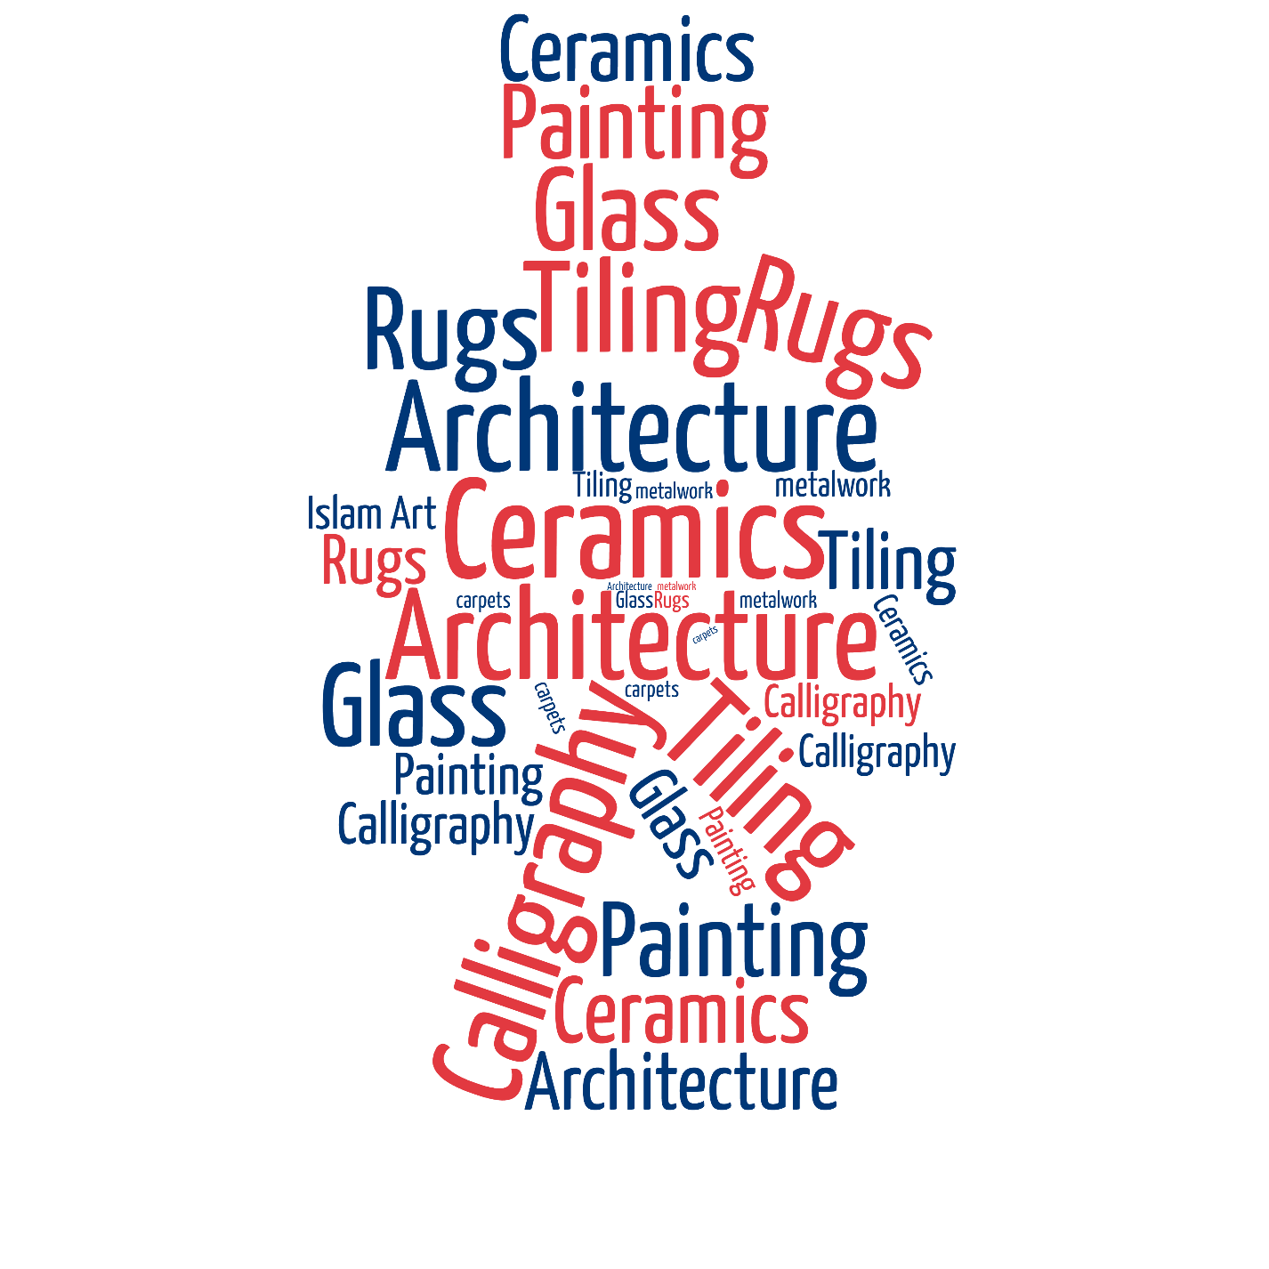

References
Grabar, O. (1964). Islamic Art and Byzantium. Dumbarton Oaks Papers, 18, 67.

